2017 Leaving Cert Physics Solutions (Ordinary Level)

2017 no.1

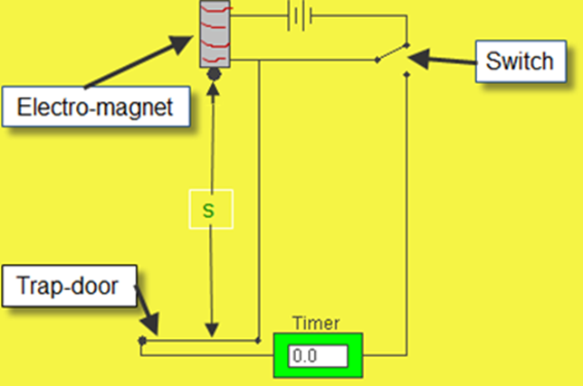
- Draw a labelled diagram of the apparatus used in this experiment.
See diagram

- What measurements were taken to calculate g?
distance s and time t
- How were these measurements taken?
measure length using a metre stick
measure the time using a stop watch /timer
- How were these measurements used to calculate g?
Substitute for t and s into the equation
g = (2s)/t²
- State two precautions which the student might have taken to get an accurate result.
Avoid parallax error, etc.
Use the smallest time value recorded for t, etc.
Use accurate digital timer, etc.

2017 no.2

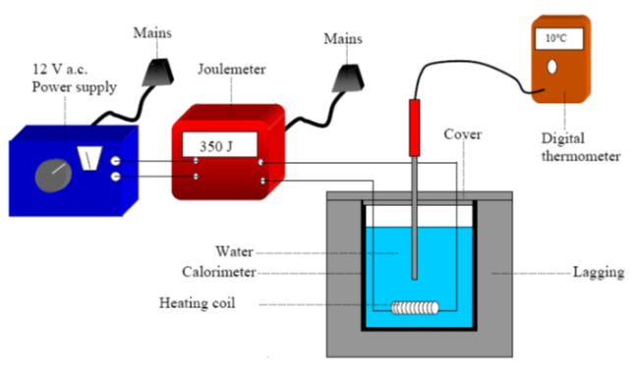
- Draw a labelled diagram of the apparatus used in this experiment.
- What measurements were taken during this experiment?
mass and temperature

- How was the mass of the substance determined?
(mass of calorimeter and water) – (mass of calorimeter)
- How was the specific heat capacity of the substance determined?
Energy supplied = (mcΔθ)cal + (mcΔθ)water
- State one precaution which the student might have taken to get an accurate result.
Lagging, use sensitive thermometer, ensure that heating coil is completely immersed in the liquid, stir the liquid, large temperature change, no parallax when reading the thermometer etc.

Partial answer e.g. repeat / average / no parallax (2)

2017 no.3

- Draw a labelled diagram of the apparatus used in this experiment.

- How did the observer know that the apparatus was correctly arranged to record the data?
the (inverted) image was in (sharp) focus (on the screen)

- Indicate on your diagram the measurements that were taken.
distance from the object/crosswire to the mirror = u
distance from the image/screen to the mirror = v

- Calculate the value of the focal length f of the mirror, using the data above.

f = 10.07 cm

f = 10.12 cm

f = 10.086 cm

Average focal length = 10.07 cm

- Why might it be an advantage to use a darkened room when carrying out this experiment?
The image might be clearer, helps to get a sharp image etc.

2017 no.4

- Draw a labelled diagram of the apparatus used in this experiment.
See diagram

- How was the value of the resistance of the metallic conductor measured?
ohmmeter / multimeter set to read ohms

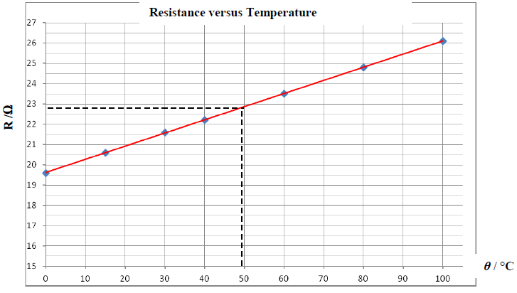
- Using the data in the table draw a graph, on graph paper, to show the variation of the resistance of the metallic conductor with temperature.
- What does the graph tell you about the relationship between the resistance of a metallic conductor and its temperature?
Resistance increases with temperature. The relationship is linear but not proportional.

- Use your graph to find the temperature of the metallic conductor when it has a resistance of 22.8 Ω.
See graph. Acceptable answer is between 47 ⁰C and 50 ⁰C

2017 no.5
Answer any eight of the following parts, (a), (b), (c), etc.
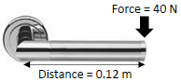
- Name an example of (i) a vector quantity and (ii) a scalar quantity.

- Calculate the moment of the force applied in the diagram.
Moment of a force = Fd = 40 × 0.12 = 40 × 0.12 = 4.8 N m

- Choose from the list below the instrument used to measure (i) electrical current and (ii) length.
ammeter metre stick
- Conduction is one method of heat transfer. Name the other two methods.
convection, radiation
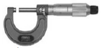
- Name the instrument shown.
micrometer /screw gauge
- State one common use for a convex lens.
magnification, (eye) glasses, binoculars, contact lenses, camera, etc.
- Resonance can cause a wine glass to shatter. What is resonance?
transfer of energy between bodies at the same frequency // at natural frequency
- Name one source of voltage.
cell, battery, power supply,(charged) capacitor, etc.
- What sub-atomic particle is released by the photoelectric effect?
electron
- Name one method of detecting radiation.
Geiger-Muller tube, Geiger counter, solid state detector, cloud chamber, bubble chamber, GLE, photographic film, radiometer,

2017 no.6
- Explain the underlined terms.
Force: causes an object to accelerate
acceleration: rate of change of velocity
gravity: force of attraction between masses
- What form of energy does the pod have due to its motion?
kinetic (energy)
- What form of energy does the pod have at its highest point?
potential (energy)

- Why do the occupants experience apparent weightlessness at the pod’s highest point?
freefall / no reaction force / no support force
- Calculate the potential energy stored in the springs before the pod is released.
PE = mgh = 400 × 9.8 × 50 = 196 000 J
- Draw a diagram to show the forces acting on the pod when it is released.
diagram to show: downward force/ weight, upward force / tension
- Calculate the momentum of the pod when it has a speed of 8 m s^{‒1}.
p = mv = 400 × 8 = 3200 kg m s⁻¹
- State one energy loss that might prevent the pod from reaching its maximum height.
friction / air resistance

2017 Question 7
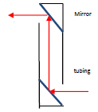
- What is meant by reflection of light?
rebounding / bouncing of light from a surface
- State the laws of reflection.
angle of incidence is equal to the angle of reflection
incident ray, the normal, and the reflected ray are coplanar
- Draw a diagram to show how a periscope works.

- Explain why the driver can read the word correctly in the mirror.
(the mirror causes an apparent) left to right reversal

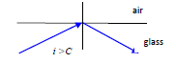
- Draw a labelled diagram to show how total internal reflection occurs.
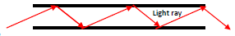
- Draw a labelled diagram to show how an optical fibre transmits light along its length.

- Calculate the angle at which total internal reflection occurs.
$n_{g}=\frac{1}{\sin{C}}$ $\sin{C}=\frac{1}{n_{g}}$ $\sin{C}=\frac{1}{1.5}$ $\sin{C}=0.66$ $C=\sin^{-1}{0.66}$ C = 41.8⁰

2017 Question 8
- What is meant by the frequency of a wave?
number of waves passing per second

- State the relationship between the frequency of a wave and its wavelength.
c = fλ

- What name is given to this effect?
Doppler effect
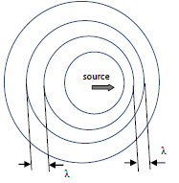
- Explain, with the aid of a labelled diagram, how this phenomenon occurs.
Ahead of the moving source, the crests are closer together than crests from the stationary source would be.
This means that the wavelength is smaller and the frequency is greater (more crests per second passing over the observer).
The opposite happens if the source is moving away from the observer.

- Name one practical application of this phenomenon.
speed gun, (measuring) red shift, ultrasonic scanners, imaging
used to study blood flow, used to study heart beat, weather forecasting, etc.

- What does this indicate about the difference between sound waves and light waves?
light travels faster than sound

- State one other difference between sound waves and light waves.
sound waves are longitudinal: light waves are transverse
sound waves need a medium: light waves don’t
light waves may be polarised: sound waves cannot be polarised

- Calculate the difference in time the runner would receive
$time=\frac{distance}{speed}=\frac{100}{330}$ = 0.3 s

2017 Question 9
- What is a magnetic field?
a region/space where a magnetic force is felt
- State one example of a good conductor and one example of a good insulator.
Conductor: copper
Insulator: plastic
- Name the unit of voltage.
volt / V

- What happens to the wire when current flows through it?
it moves // it experiences a force
- What happens when the direction of the current is reversed?
wire moves in the other direction
- Name one device based on this effect.
electric motor, speaker, (moving coil) galvanometer, etc.

- What is observed on the voltmeter when neither the wire nor the magnet move?
no reading / no deflection / nothing
- What is observed on the voltmeter when either the wire or the magnet is moved?
deflection / pointer moves /
- Name a scientist whose law is associated with this phenomenon?
Faraday / Lenz
- Name one other effect.
heating // chemical

2017 Question 10
- Name three types of radiation.
alpha / α, beta / β, gamma / γ
- Which type of radiation has no charge?
gamma / γ
- Which type of radiation is the least penetrating?
alpha / α
- Which type of radiation is not deflected by magnetic fields?
gamma / γ
- State one danger associated with nuclear radiation.
leukaemia, cancer, skin burns, hair loss, kills cells, damage DNA, etc.
- State one precaution that should be taken when handling radioactive substances.
protective clothing, tongs, etc.
- What is nuclear fission?
splitting of a large nucleus into two smaller nuclei with release of energy and neutrons
- Name a fuel used in nuclear reactors.
plutonium / Pu, (enriched) uranium / U, thorium / Th
- State the function of (a) the control rods and (b) the shielding in a reactor.
(a) control rate of reaction // absorbs neutrons
(b) prevents escape of radiation
- What is the purpose of the heat exchanger?
converts (kinetic energy) energy to heat // brings energy to the generator

2017 no.11
  - What is the function of the electricity meter?
to measure the (electrical) energy used
  - What is meant by the term a.c.?
alternating current
  - Name three safety devices found in domestic circuits.
fuse, earth, miniature circuit breaker/ (trip) switch, residual current device
  - What is the cause of most accidents associated with electrical appliances?
damaged flexes // wrongly-wired plugs
  - What is the function of the test button on an RCD?
to check that the mechanism is working properly
  - Name the pins labelled A, B and C in the diagram.
A – neutral; B – live; C – earth
  - State one precaution that should be taken when wiring a plug.
no loose strands of wire are exposed // all the screw connections are tightened // leave a little extra slack on the green/yellow wire within the plug.
  - What is the maximum power that an appliance with a 13 A plug can use when connected to a 220 V supply?
P = IV = 13 × 220 = 2860 W

2017 Question 12 (a)
- Define velocity and friction.
(i) rate of change of displacement // distance over time (in a given direction)
(ii) force (between 2 bodies in contact) which opposes motion
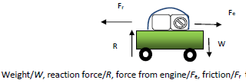
- Draw a diagram indicating the main forces acting on the car when it was accelerating.

- Calculate how long it took the car to reach its top speed.
(v = u + at 28 = 0 + 0.4t t= $\frac{28}{0.4}=70 s$

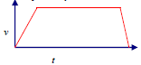
- Sketch the velocity-time graph for the journey.

2017 Question 12 (b)
- Explain the underlined terms.
heat pump: means of transferring heat from a cold region to a warm region
specific latent heat : heat needed to change the state of 1 kg of a substance
- Calculate the energy removed from the water.
E = mcΔθ = 2 × 4200 × 25 = 210 000 J
- Calculate the power of the fridge.
$$power=\frac{W}{t}= \frac{210000}{840}=250 W$$

2017 Question 12 (c)
- Define pressure and state its unit.
force per unit area
- Describe an experiment to demonstrate that the atmosphere exerts pressure.
apparatus: e.g. can of water and heat source
procedure: e.g. boil water and put on lid
observation: e.g. can collapses
accept valid alternatives e
- Calculate the volume of the balloon when it reaches the height of Mount Everest.
P₁V₁ = P₂V₂ ⇒ (10.1 × 10⁴)(2) = (3.0 × 10⁴)(V₂) ⇒ V₂ = $\frac{20.2 × {10}^{4}}{3.0 × {10}^{4}}$ = 6.7 L.

2017 Question 12 (d)
- State Coulomb’s law of force between electric charges.
force proportional to the product of charges and inversely proportional to the distance between the charges squared
- What is observed when the switch is closed?
bulb flashes
- What would be observed if a 12 V a.c. power supply had been used instead?
bulb lights (continuously)
- Calculate the charge stored on the capacitor when it is connected to the 12 V d.c. power supply.
$C=\frac{Q}{V}$ Q = CV Q = (${6×10}^{-2})(12)$ = 0.72 C
- State one application of a capacitor.
store charge / conducts a.c. /(radio) tuning / filtering / smoothing / timing /
store energy / flash camera / phone charger, etc

